**Development**

**User interfaces:**

Index page

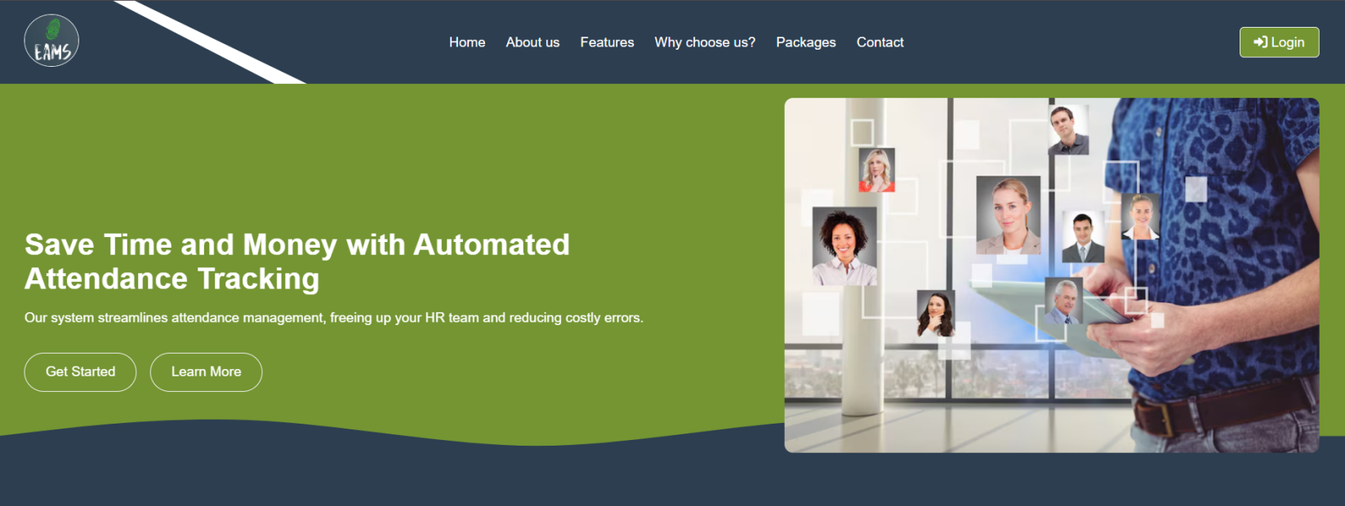

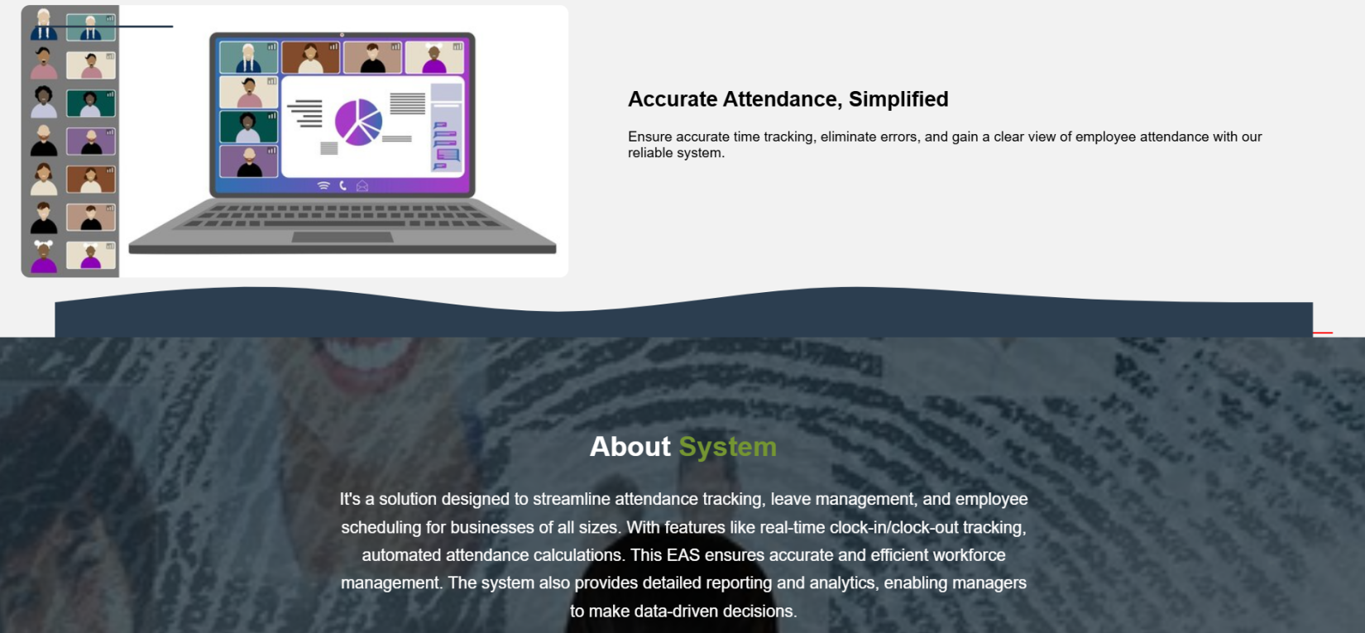

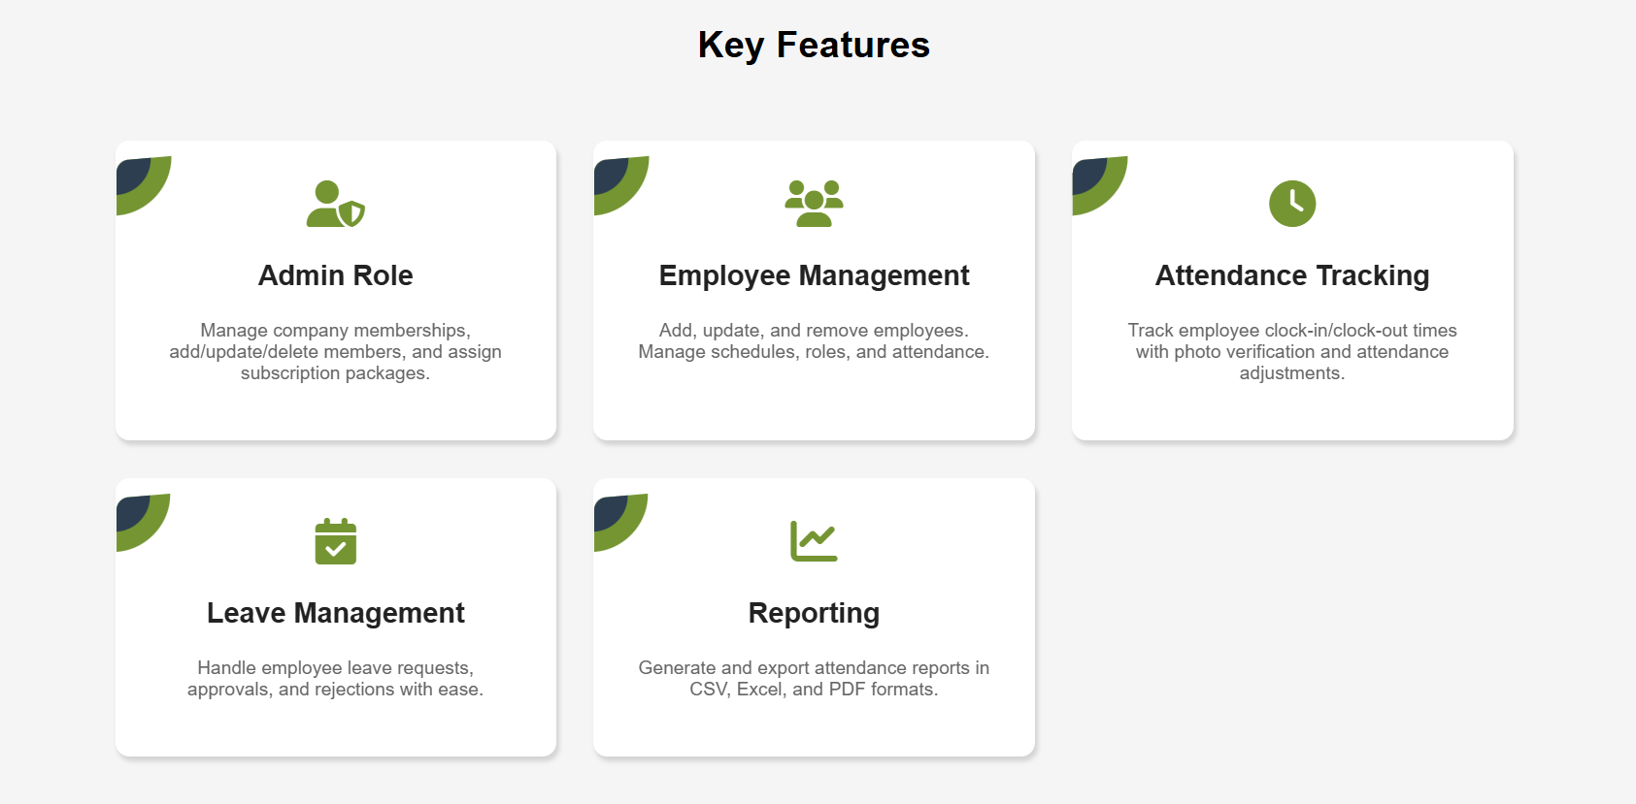

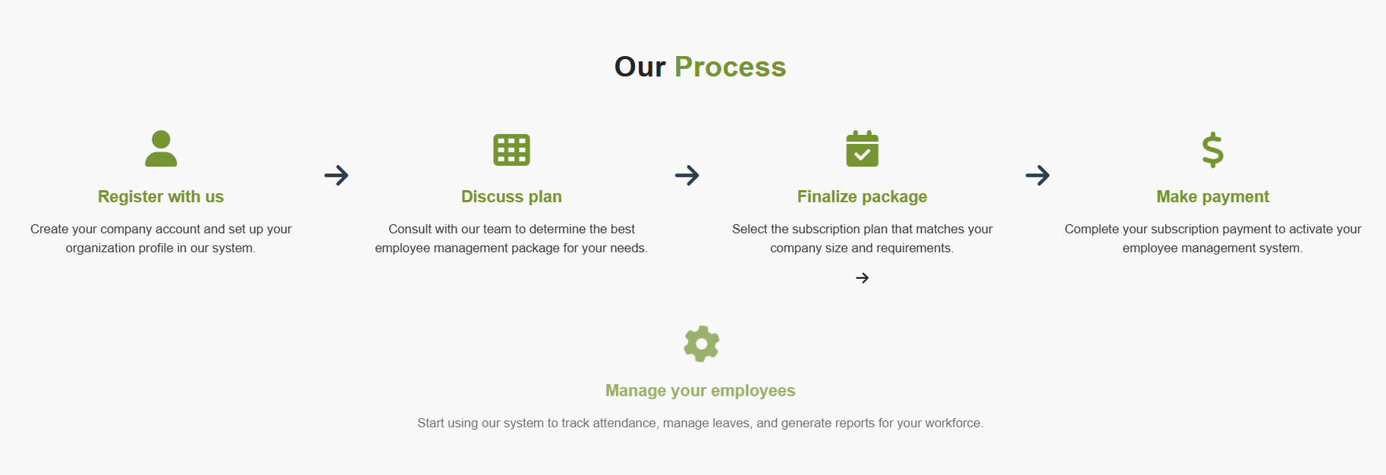

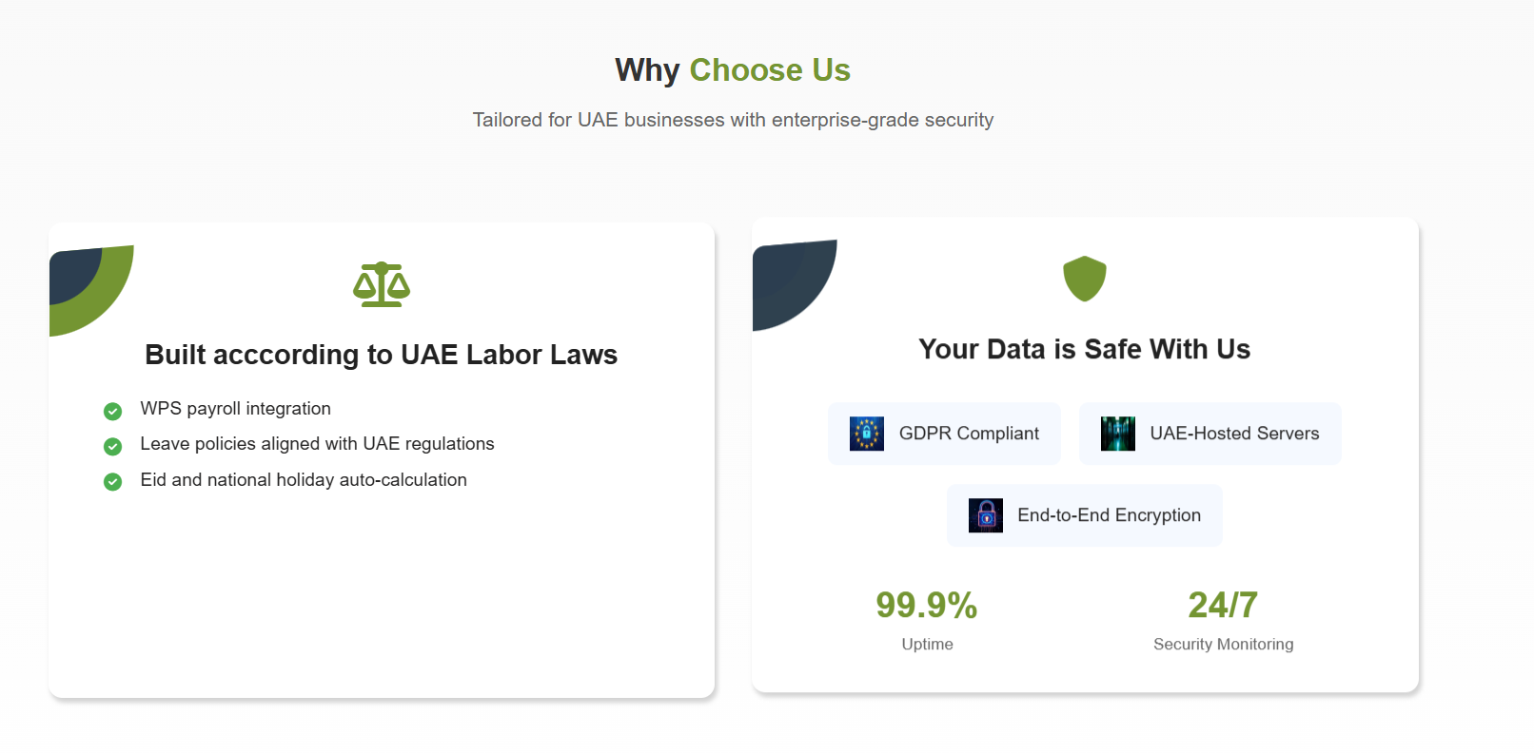

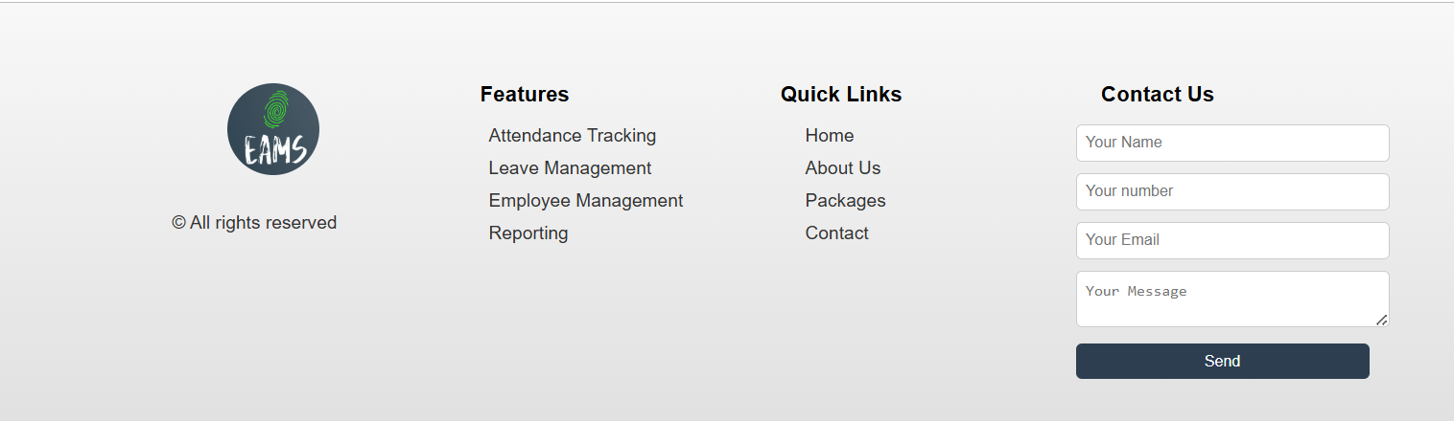

**Why to choose us:**

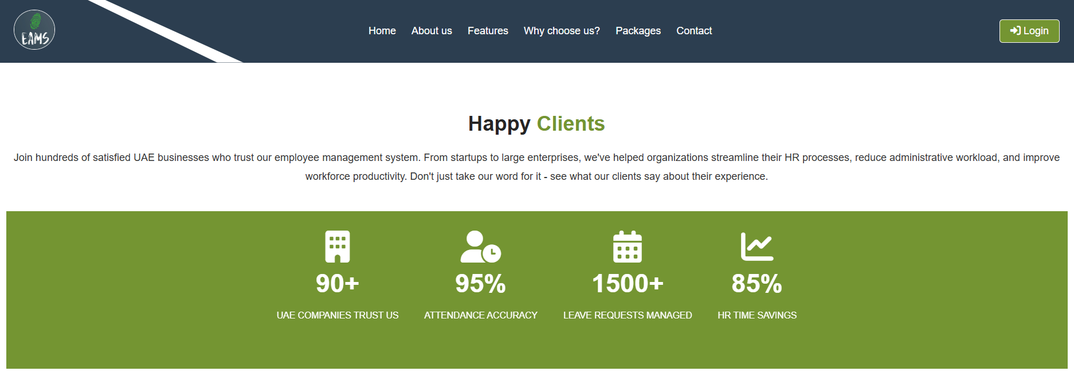

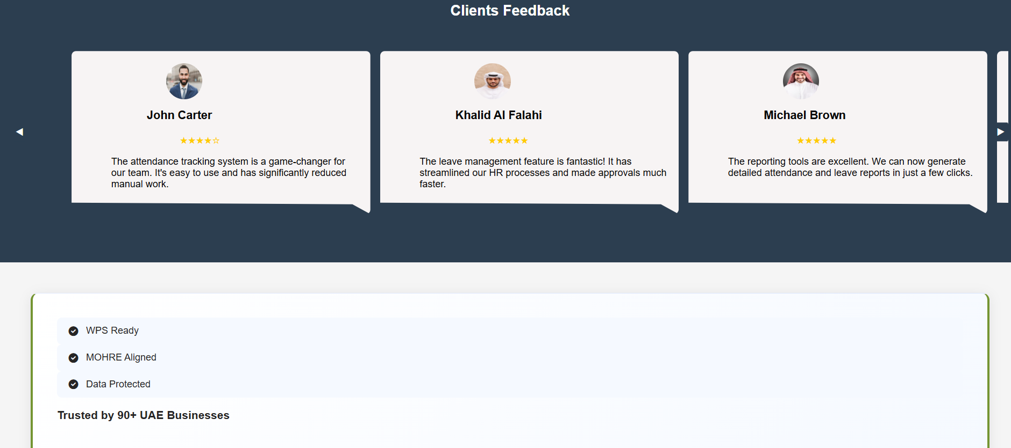

**About us**

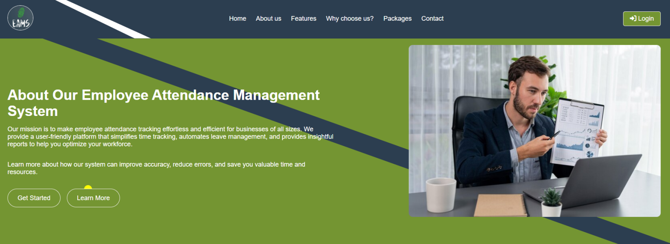

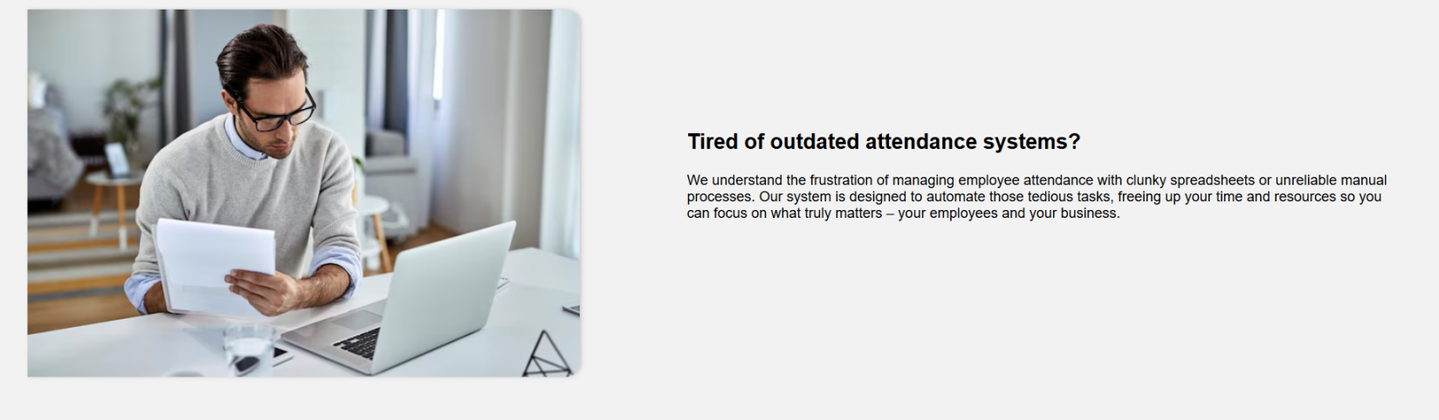

**Authentication**

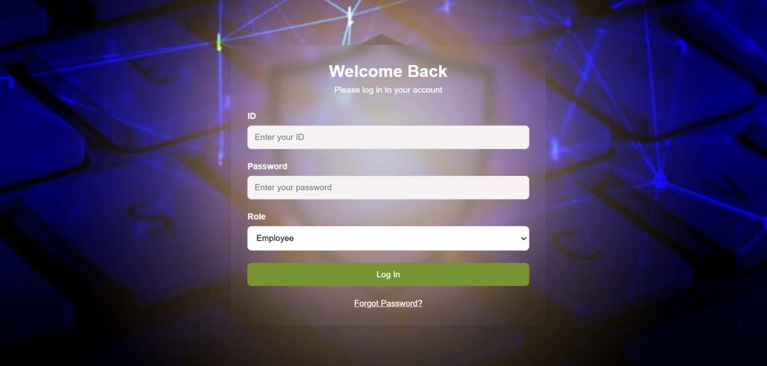

**Password reset screen**

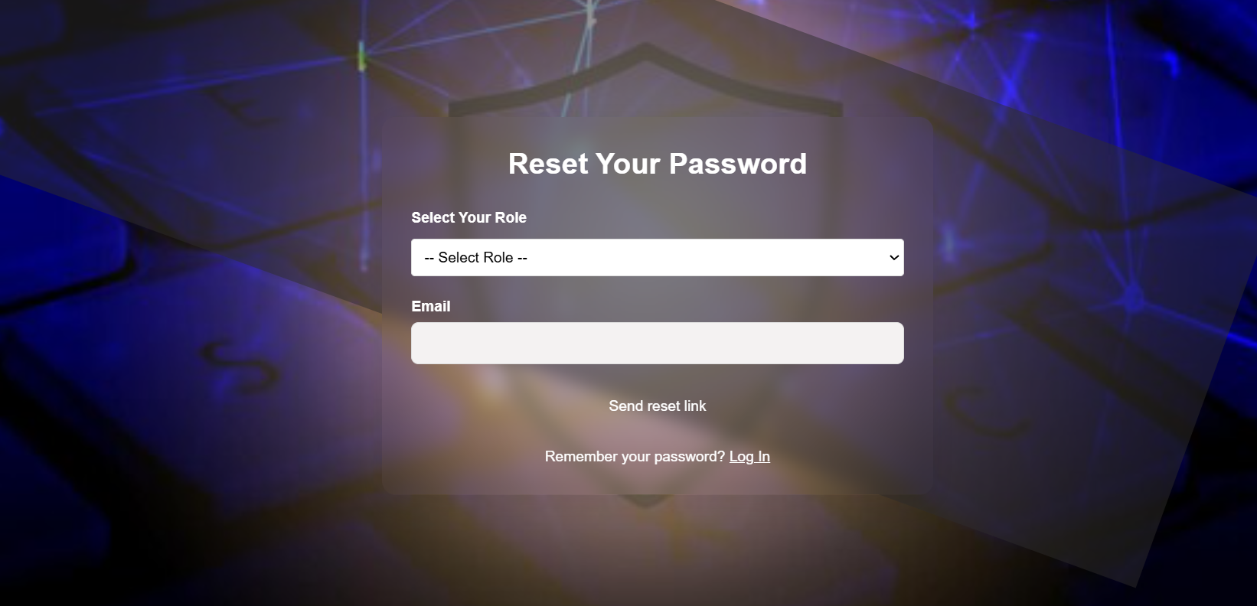

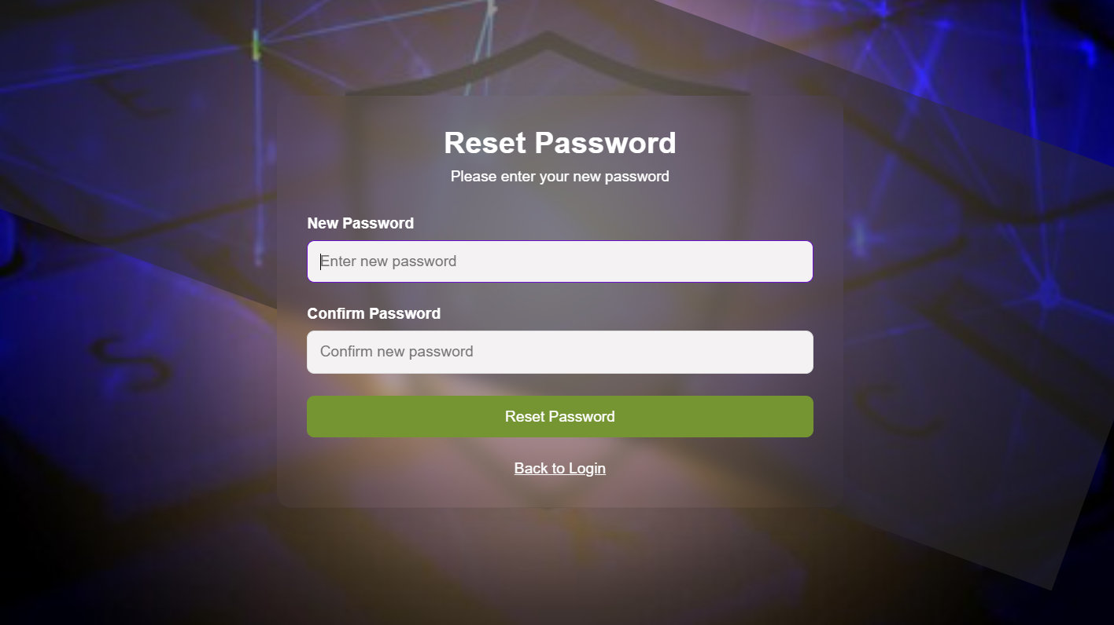

**Member Module functionality**

Profile update screen

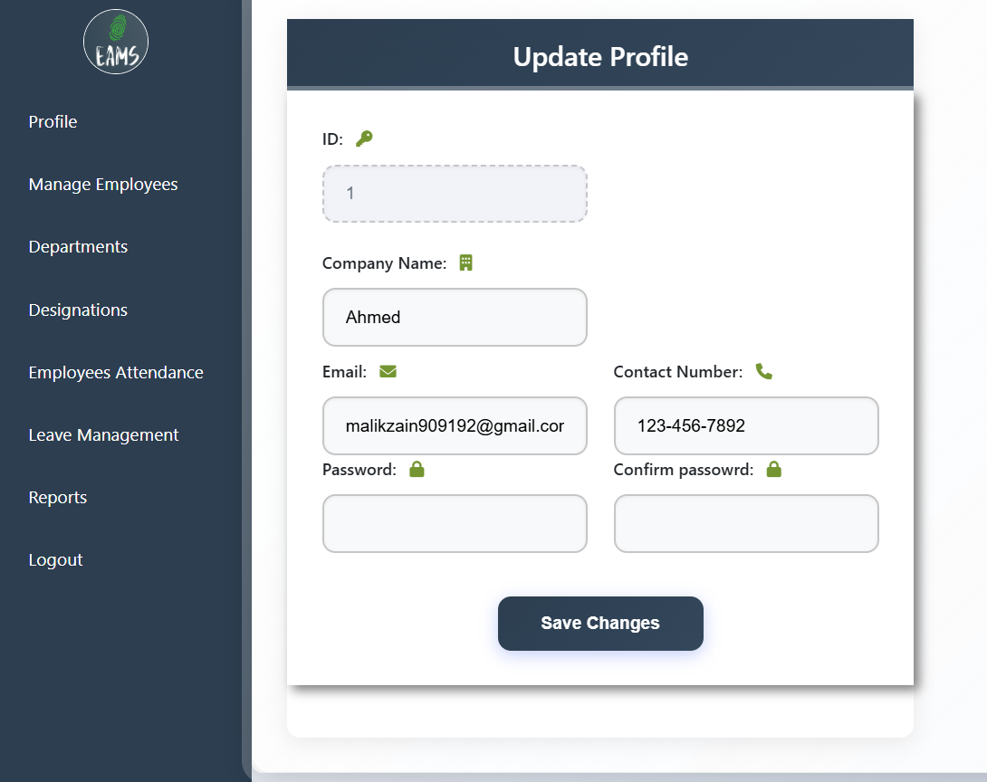

**Employees record**

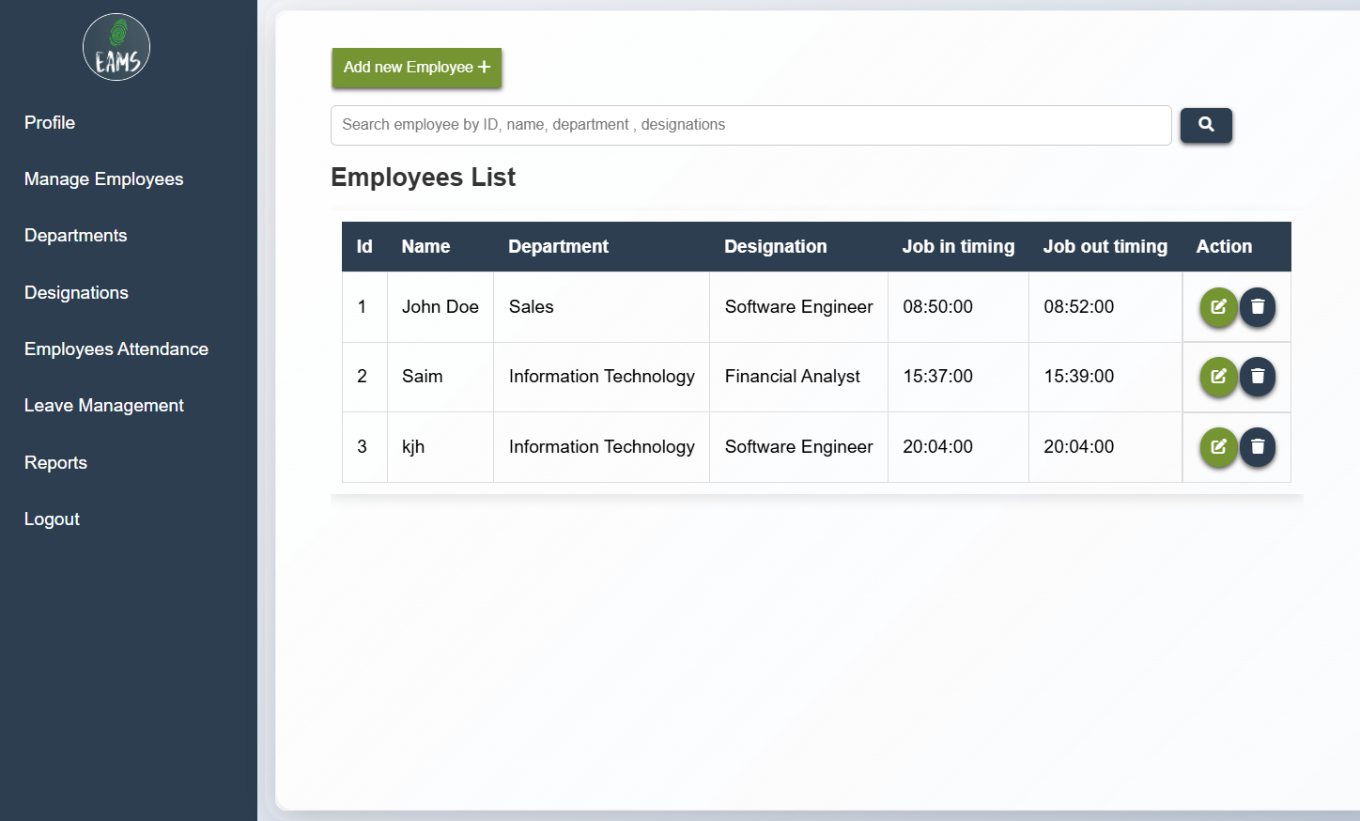

**Add employees**

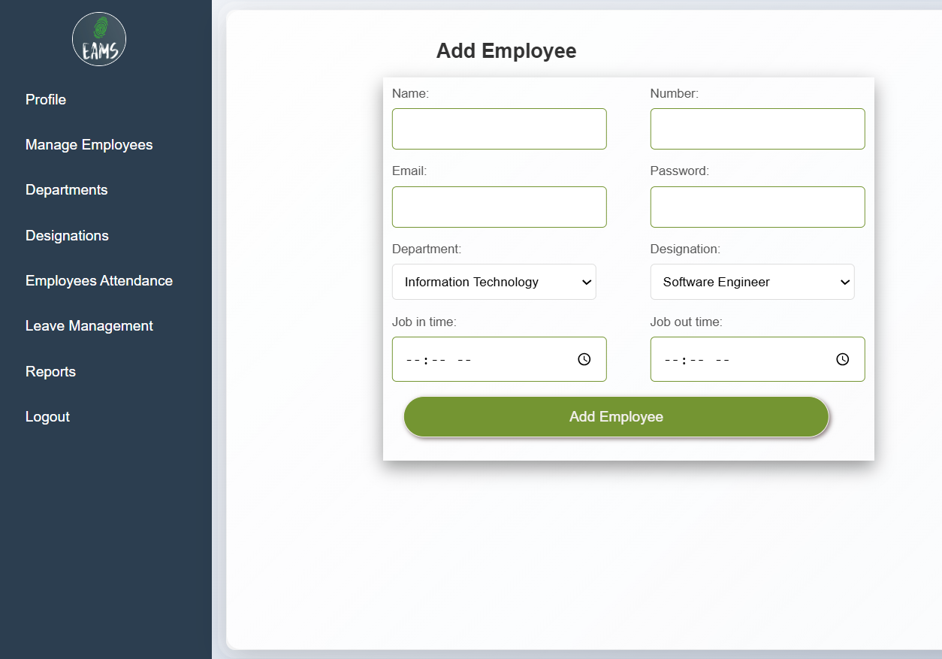

**Edit employees screen to update employees record**

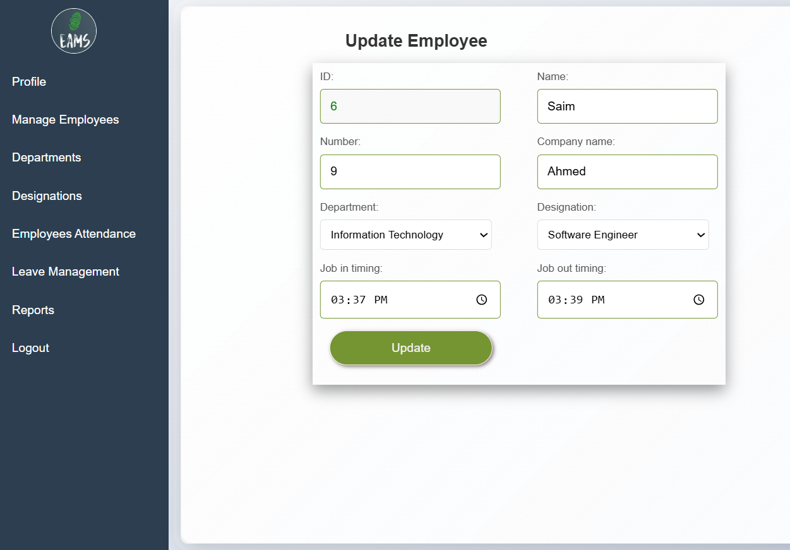

**Departments list:**

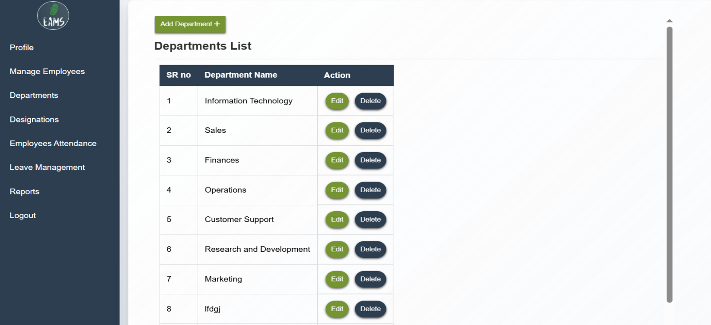

**Add department**

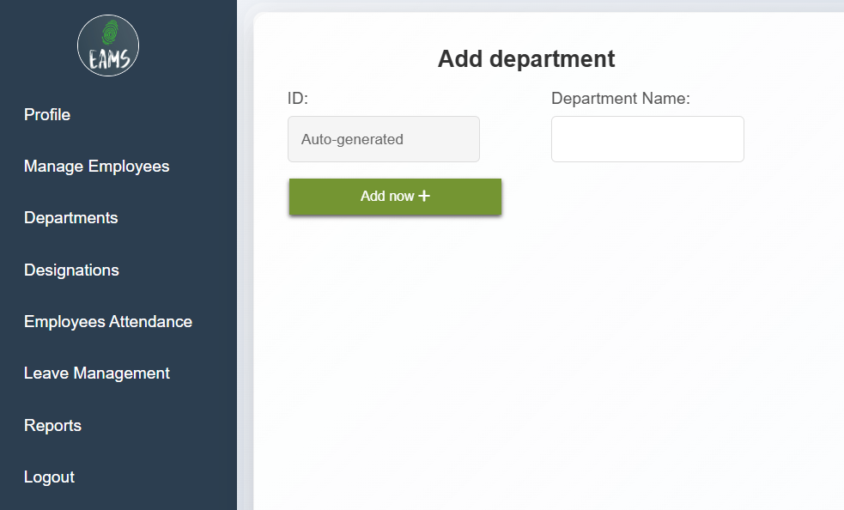

**Department delete**

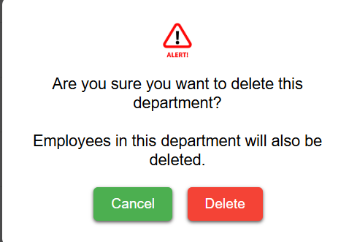

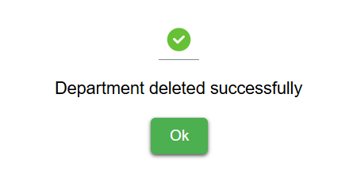

**Designations list**

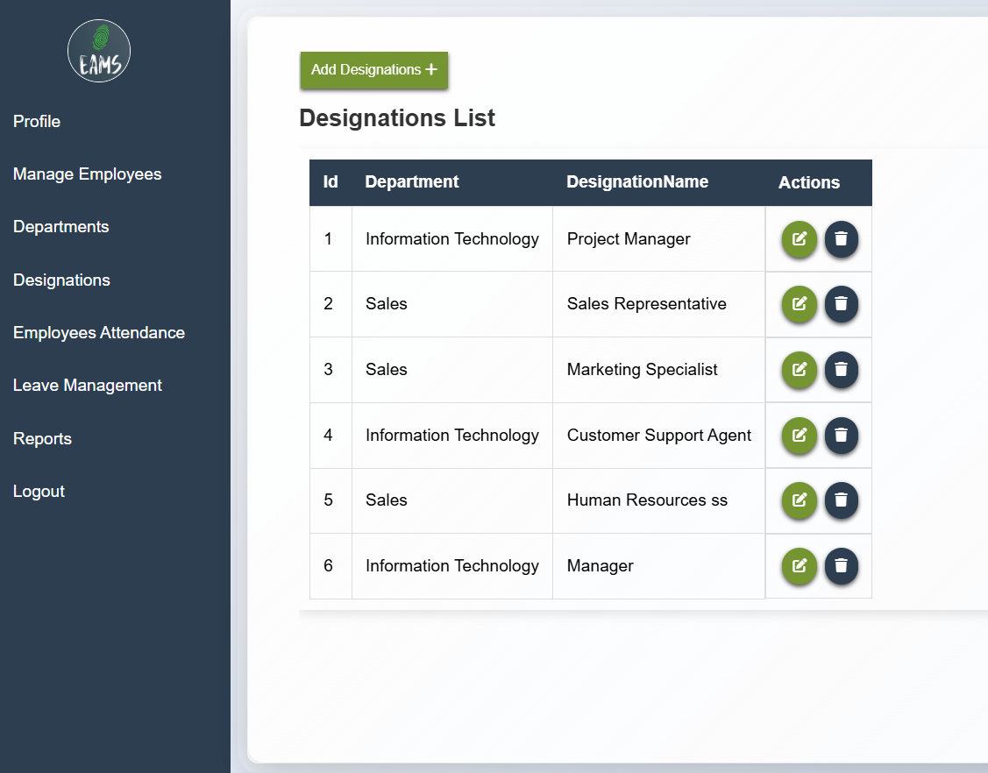

**Add designation**

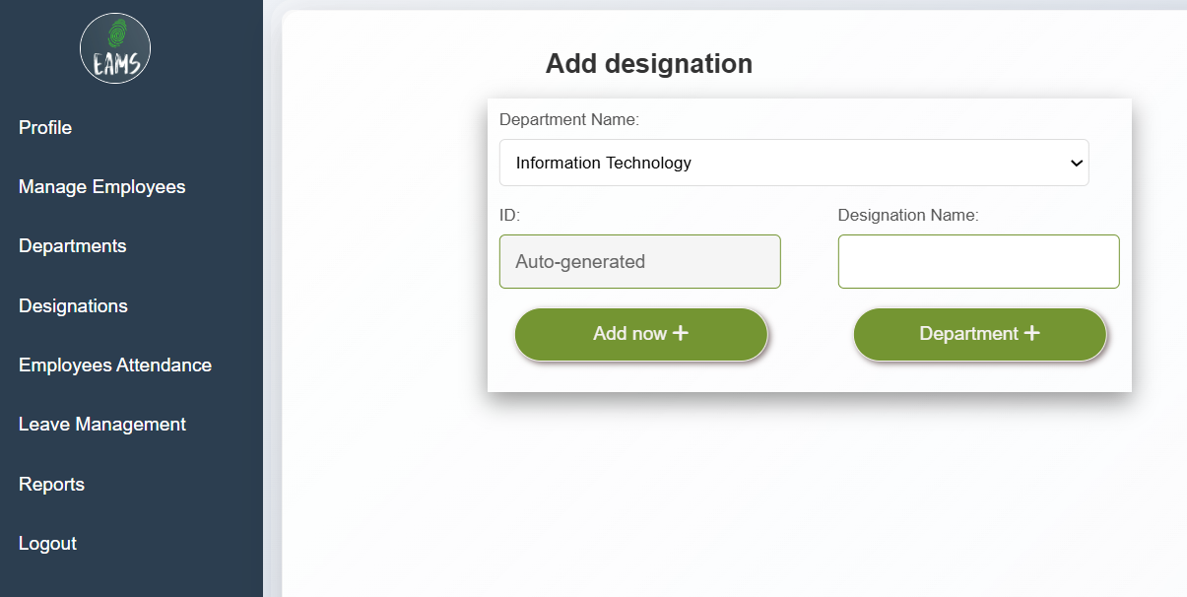

**Update designation record**

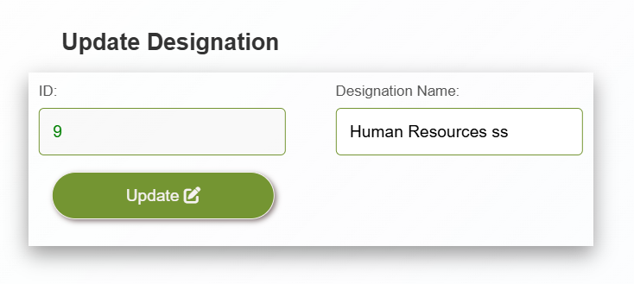

**Delete designation**

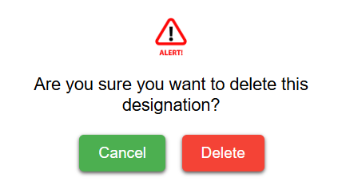

**Success message after deletion**

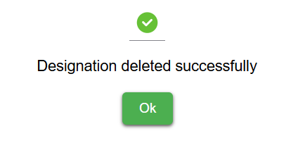

**Attendance record showing to company of his employees**

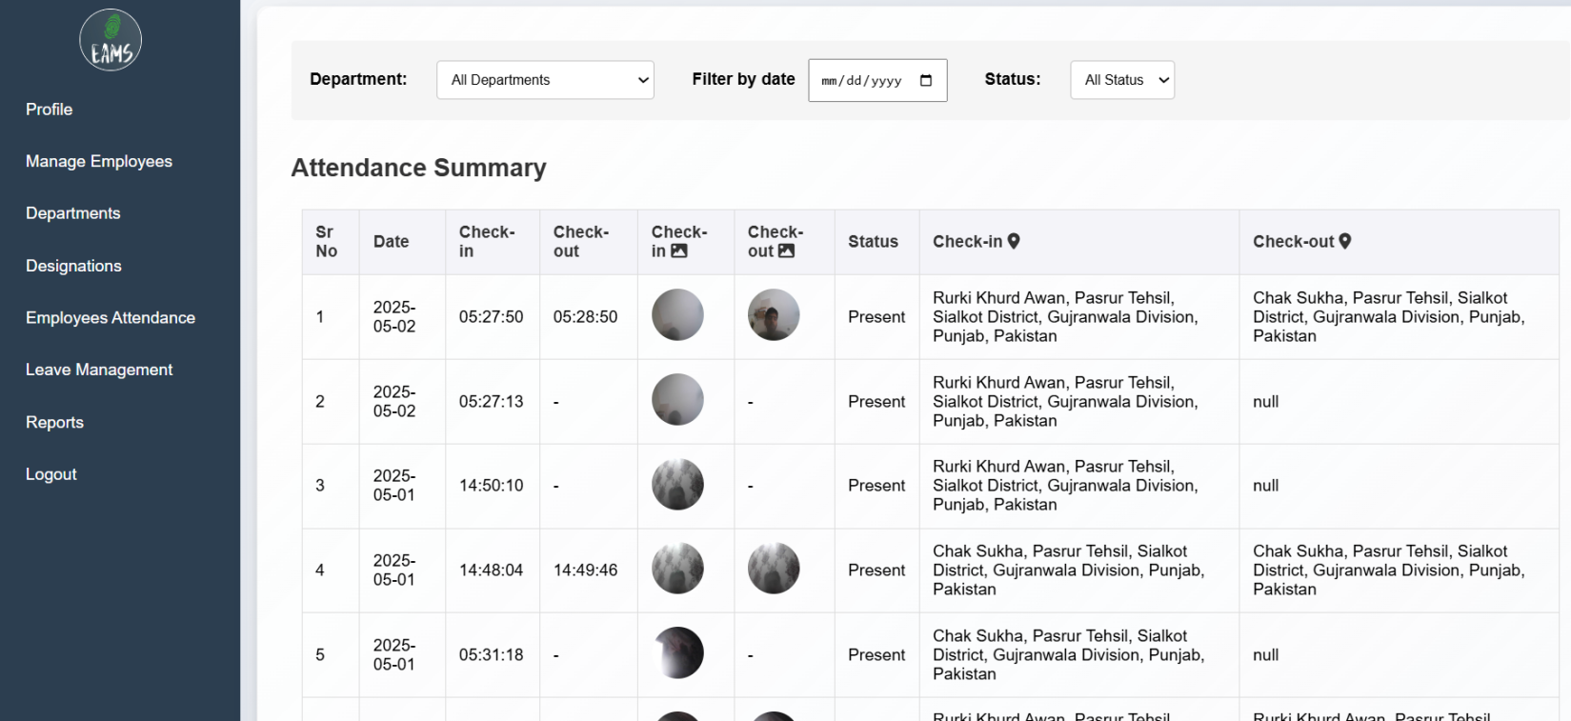

**Department wise filter**

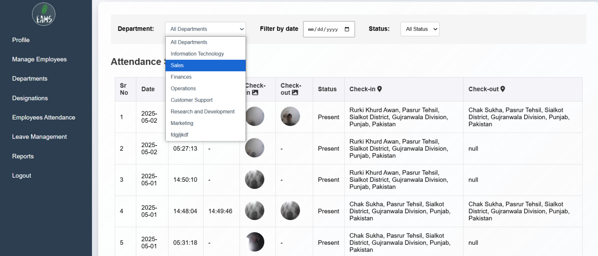

**Flter by date**

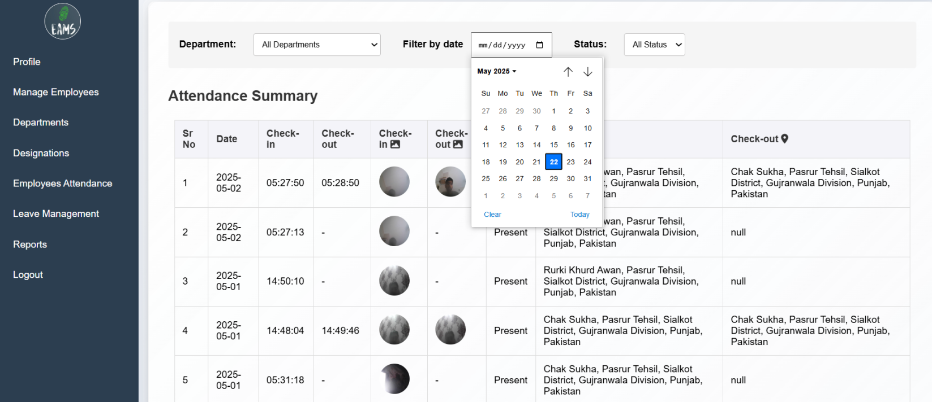

**Filter by status of attendance**

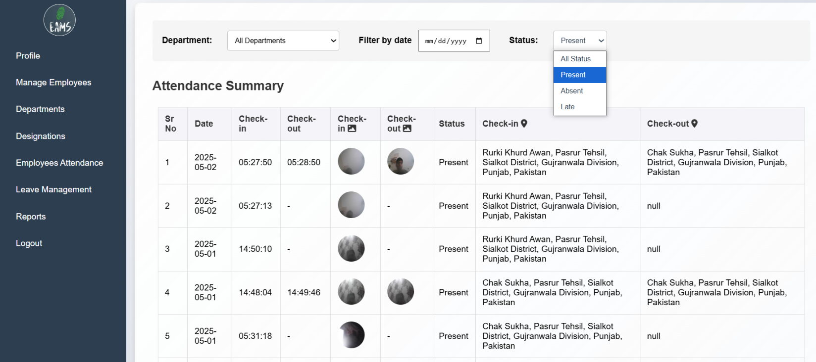

**Leave management module**

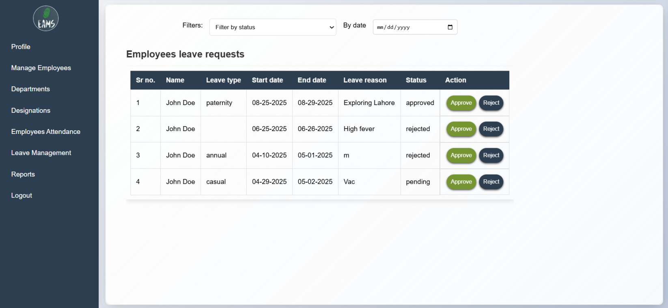

**Approve leave**

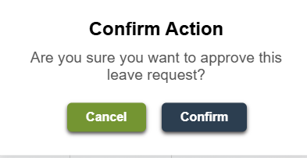

**Success message after approve**

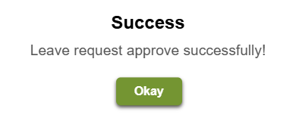

**Reject leave case**

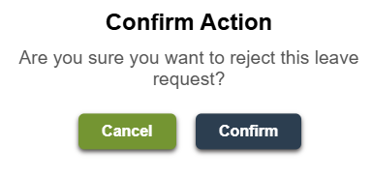

**Success message after delete**

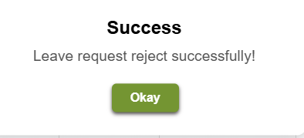

**Filter leave records by status**

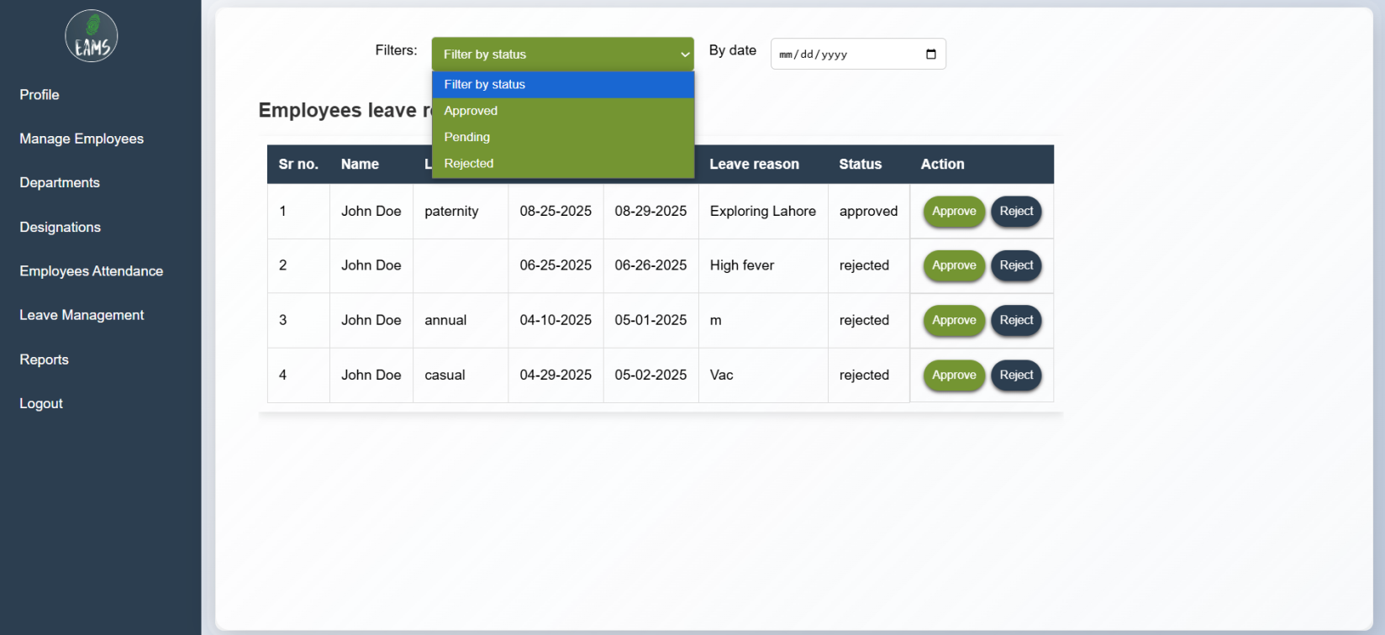

**Filter leaves by date**

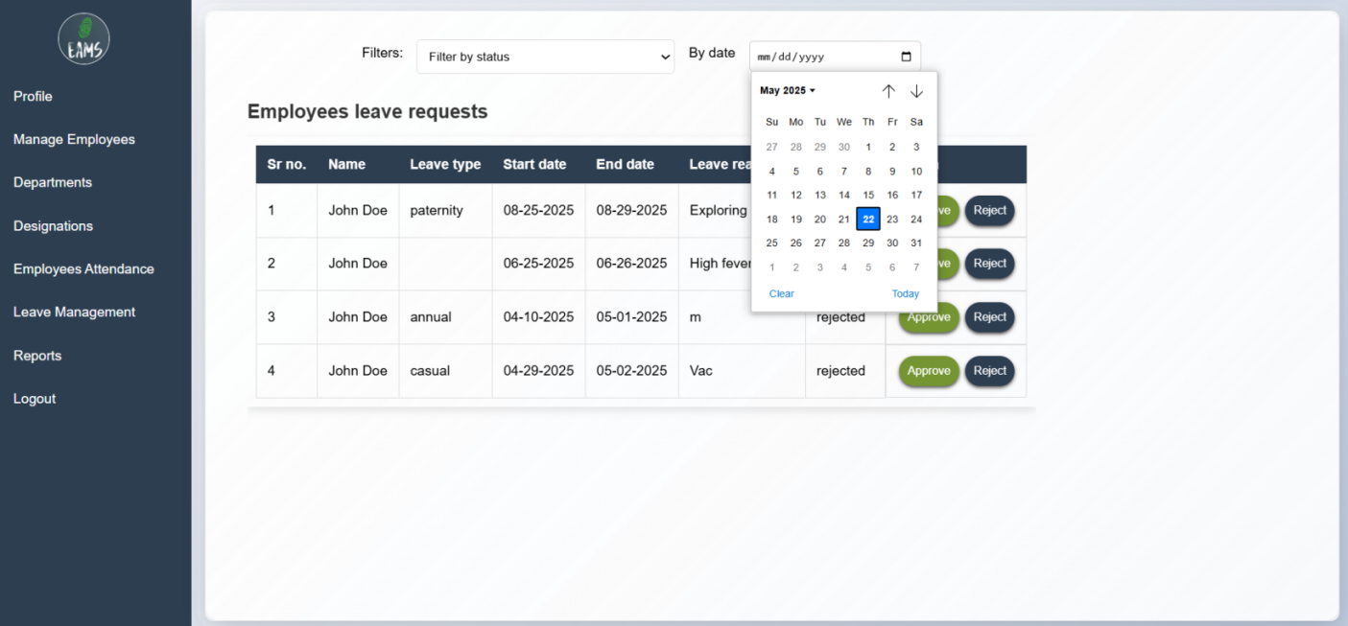

**Report of the employees**

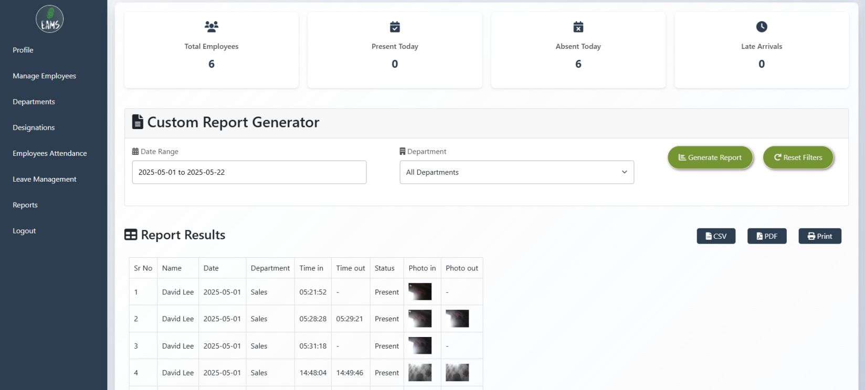

**Filter records by department**

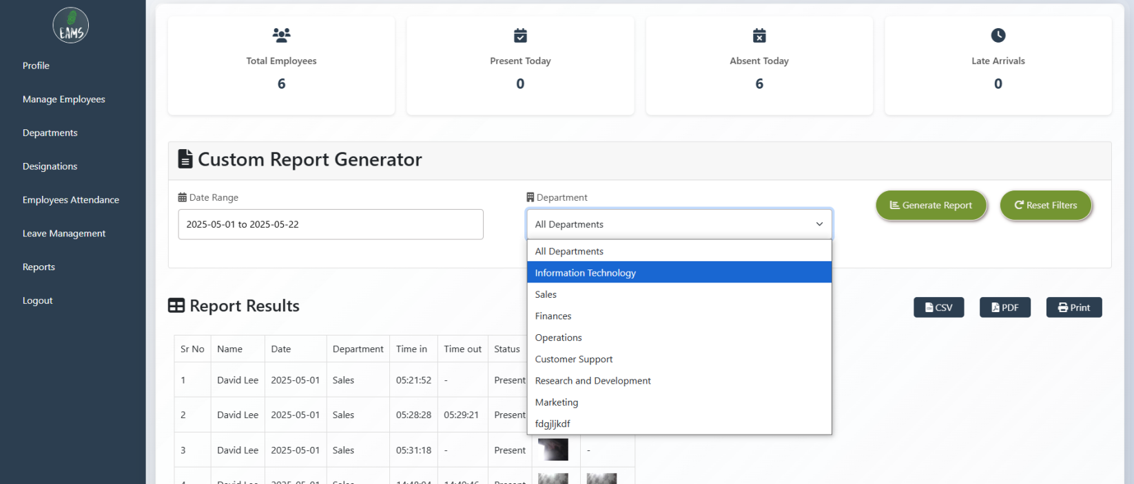

**Admin module**

**Profile update of admin**

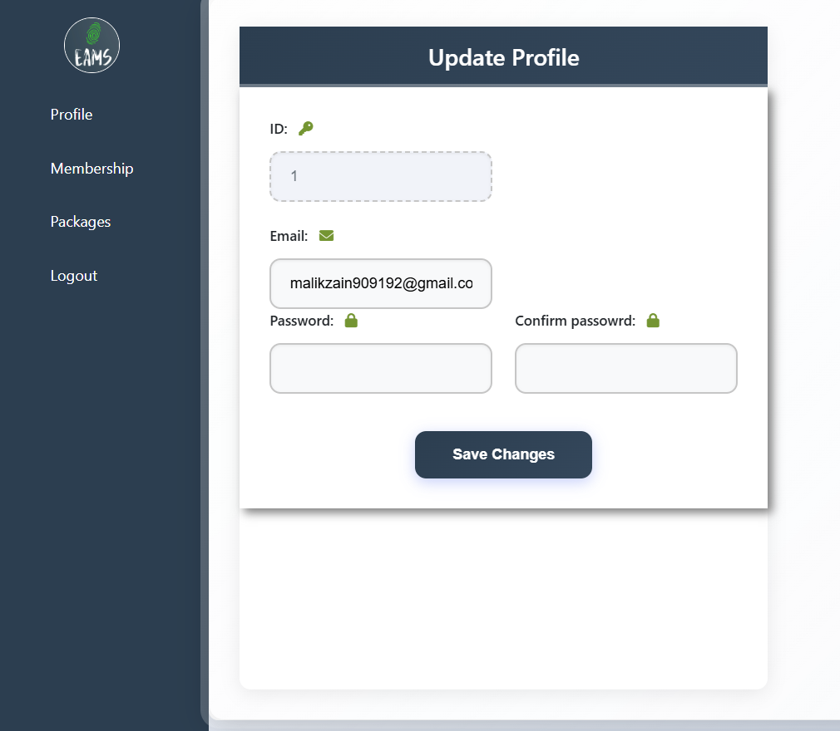

**Companies record list**

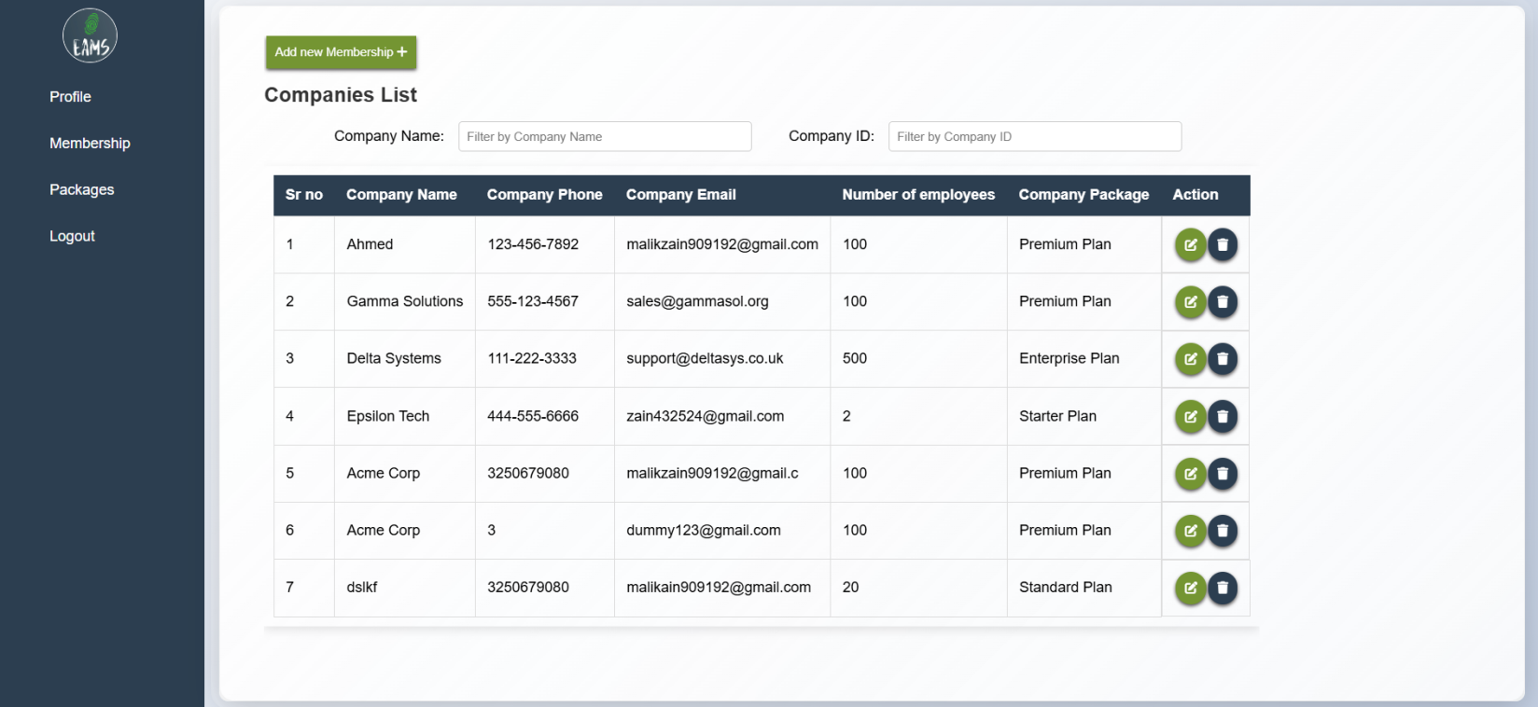

**Search company by name**

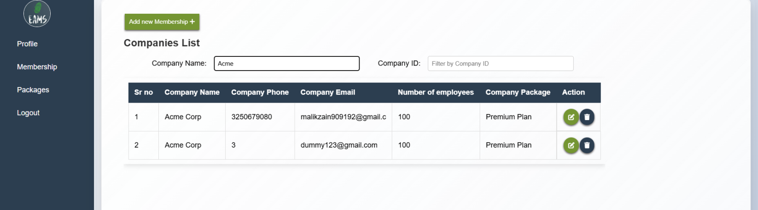

**Search company by id**

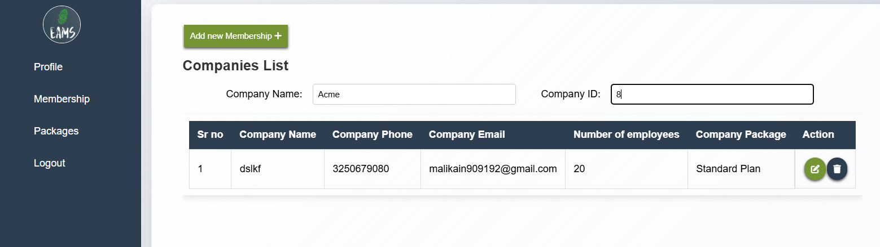

**Add new company**

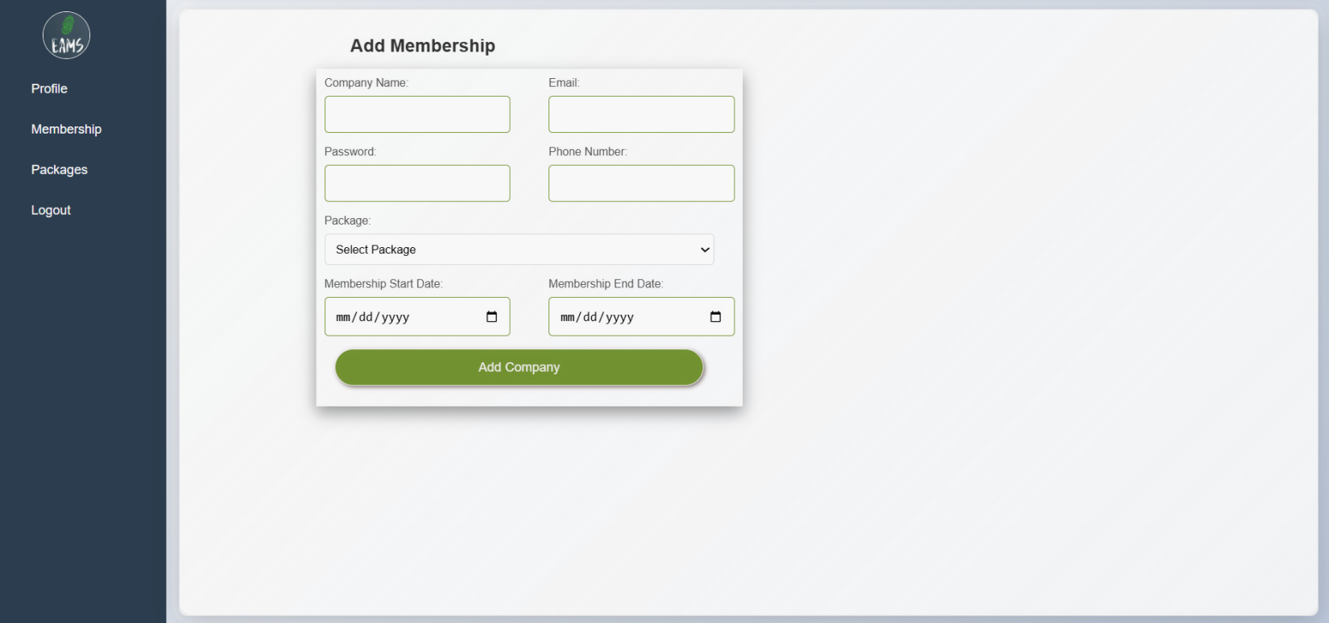

**Update company record**

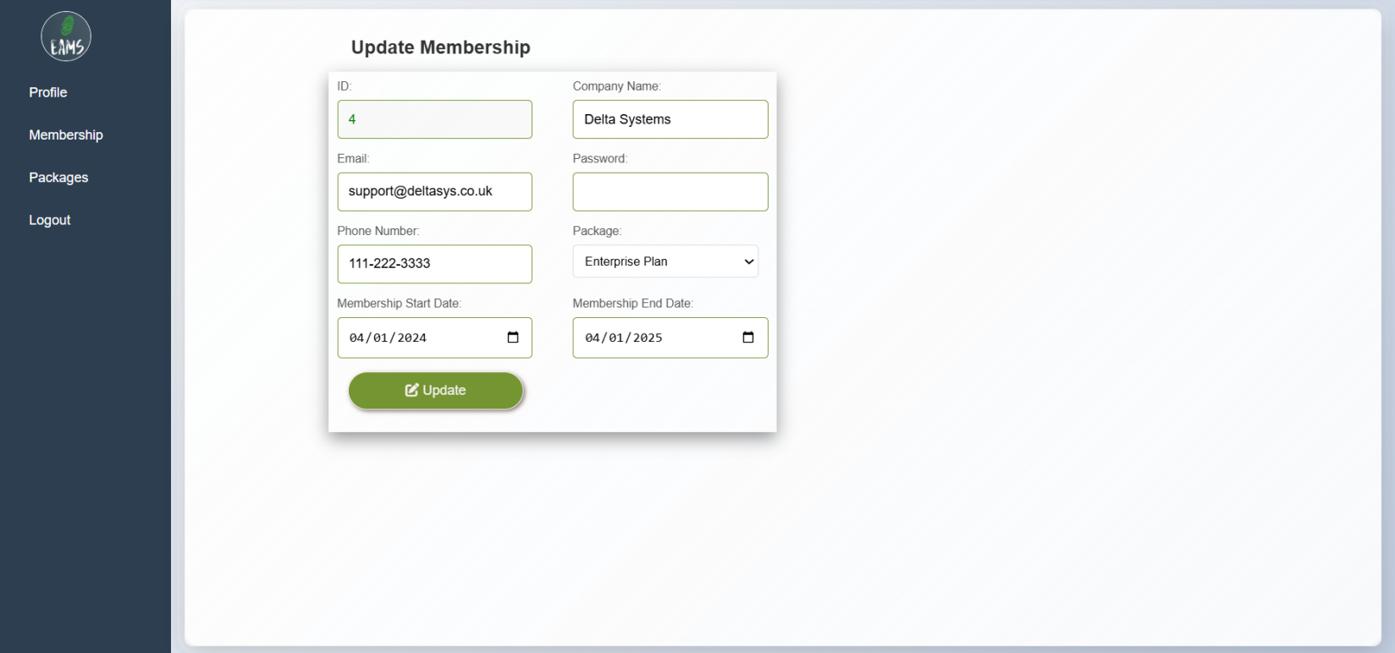

**Packages list**

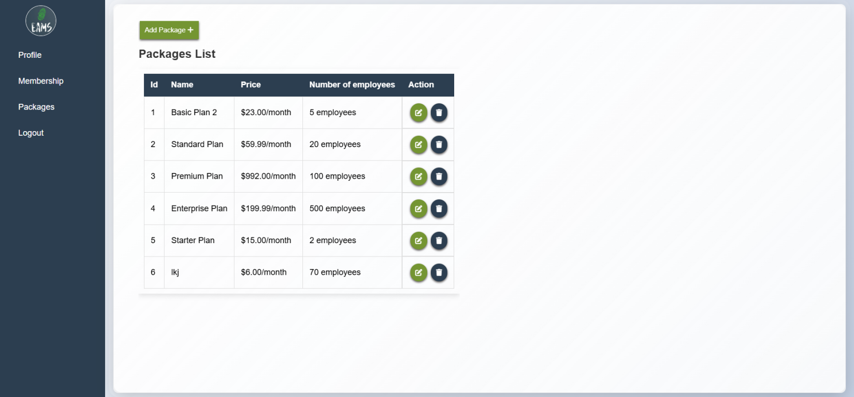

**Add package**

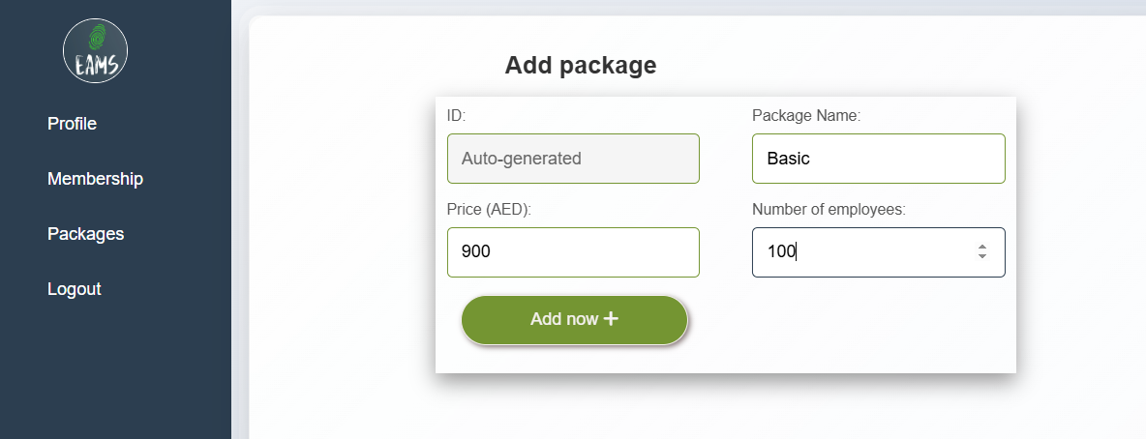

**Package update screen**

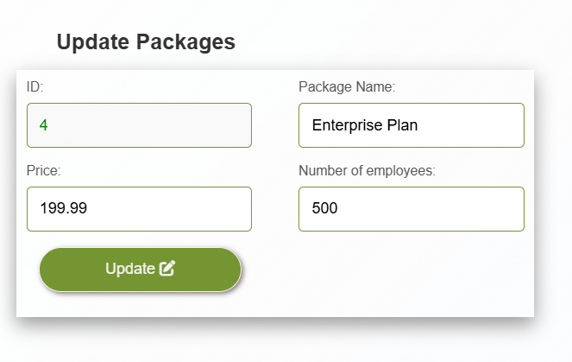

**Employees module**

**Profile update**

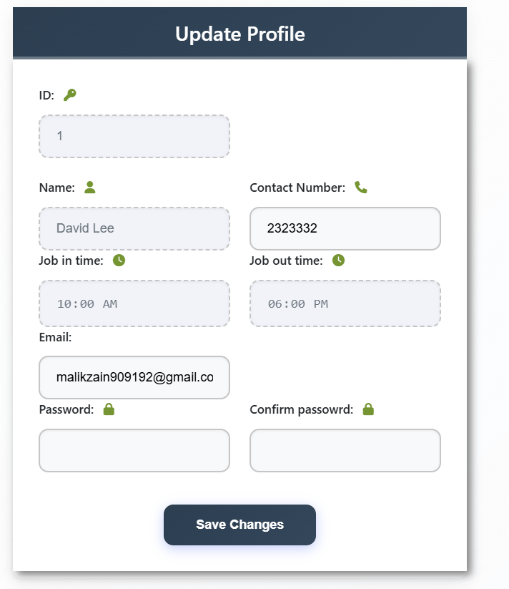

**Mark Attendance module**

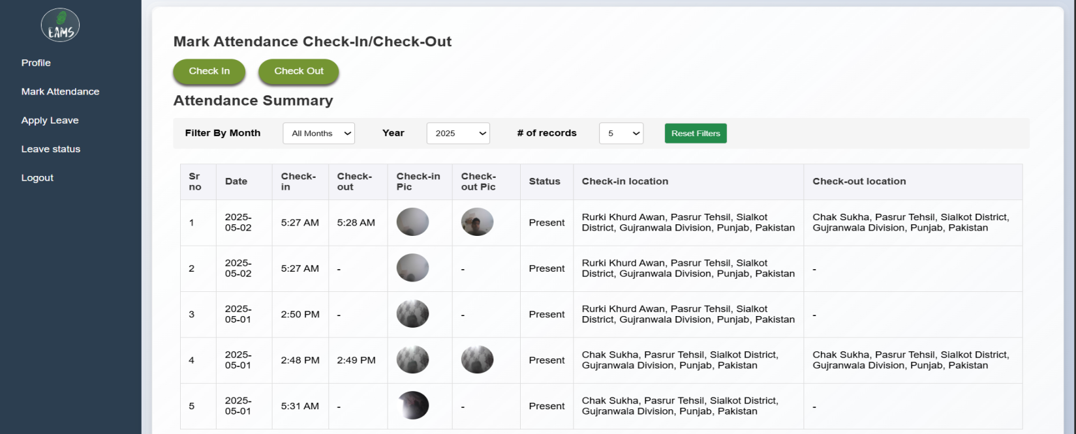

**Mark attendance**

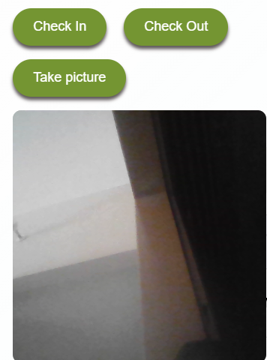

**After successful marking**

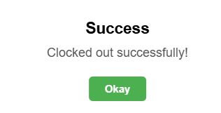

**Filter Attendance by month**

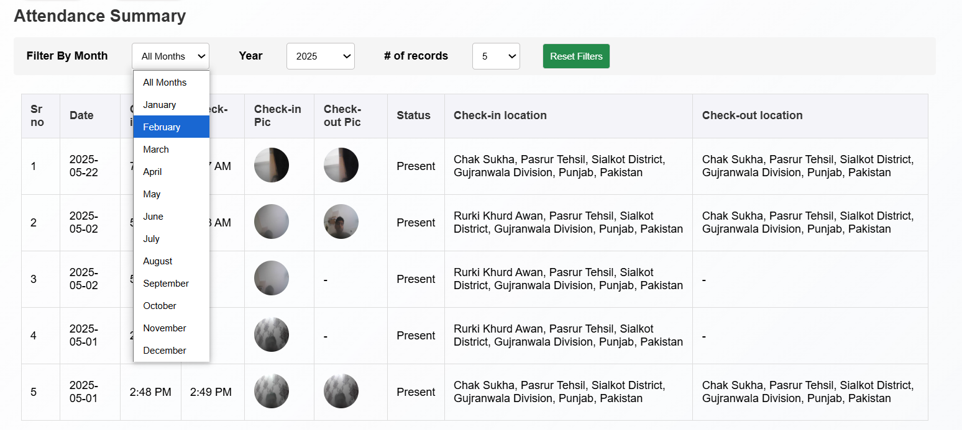

**Filter attendance by year**

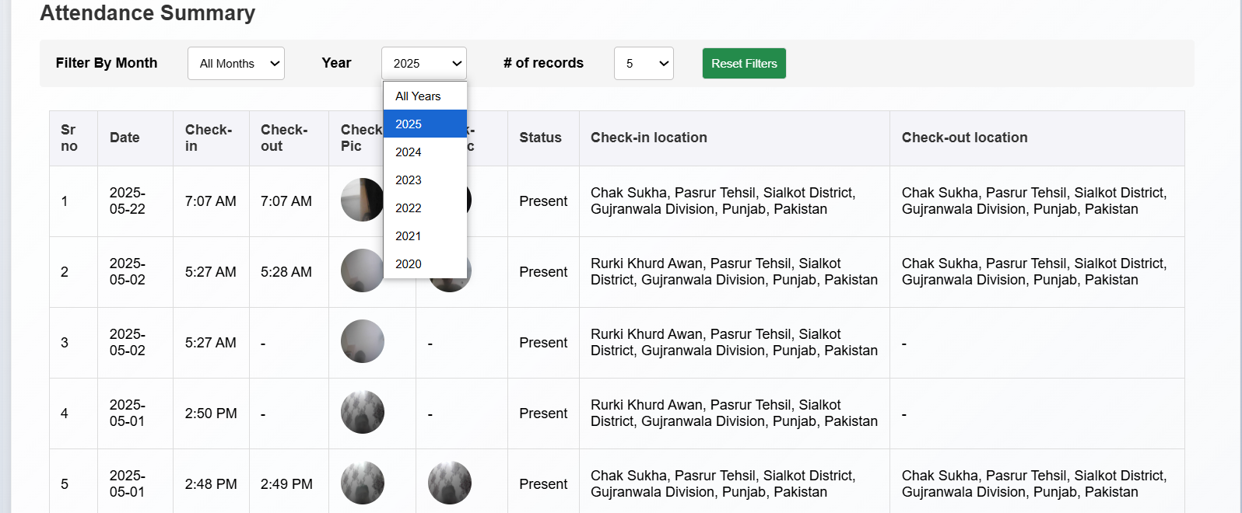

**Apply for leave**

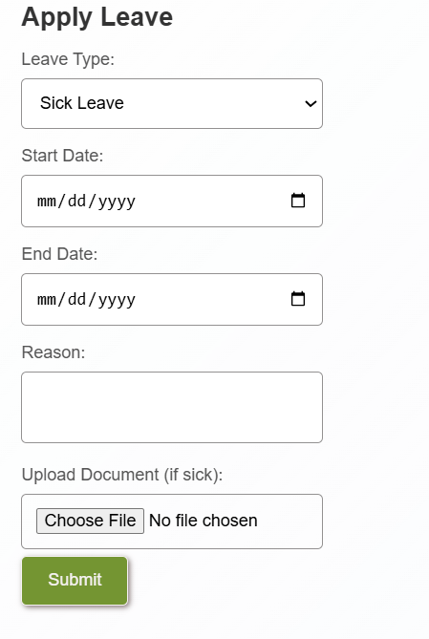

**Check leave status**

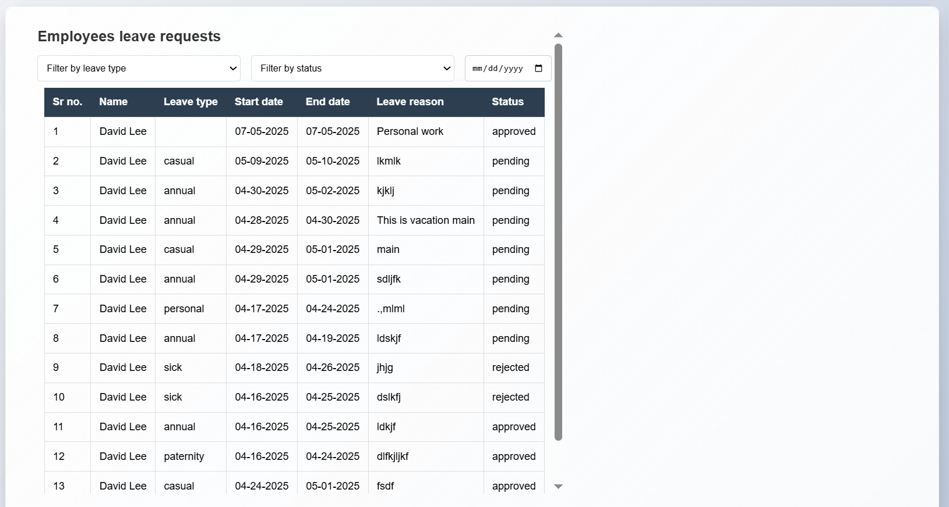

**Note: I have tested all the screens and it all providing desired results**

| **Test Case ID** | **Feature/Module** | **Date Tested** | **Steps Performed** | **Result** |
| --- | --- | --- | --- | --- |
| TC001 | Admin Login | 2025-05-12 | 1. Navigate to login page 2. Enter valid admin credentials 3. Click "Login" 2. Navigate to dashboard | ✅ Passed |
| TC002 | Company Login | 2025-05-12 | 1. Navigate to login page 2. Enter company admin credentials 3. Click "Login"   4. Navigate to dashboard | ✅ Passed |
| TC003 | Employee Login | 2025-05-12 | 1. Navigate to login page 2. Enter valid employee credentials 3. Click "Login"   4. Navigate to dashboard | ✅ Passed |
| TC004 | Password Reset (Email) | 2025-05-14 | 1. Click on "Forgot Password" 2. Submit registered email 3. Verify email received | ✅ Passed |
| TC005 | Reset Password via Email | 2025-05-14 | 1. Open password reset link from email 2. Set a new password 3. Confirm password update | ✅ Passed |
| TC006 | Add Company | 2025-05-14 | 1. Login as admin 2. Go to “Membership” module 3. Click "Add Company" 4. Submit form with valid details | ✅ Passed |
| TC007 | View Companies | 2025-05-15 | 1. Navigate to company list 2. Verify listed companies | ✅ Passed |
| TC008 | Update Company | 2025-05-15 | 1. Open a company record 2. Update fields 3. Click save | ✅ Passed |
| TC009 | Delete Company | 2025-05-15 | 1. Select a company 2. Click delete 3. Confirm deletion | ✅ Passed |
| TC010 | Add Employee | 2025-05-15 | 1. Login as company manager 2. Go to Employee section 3. Click "Add Employee" 4. Fill required fields and submit | ✅ Passed |
| TC011 | Edit Employee | 2025-05-18 | 1. Search employee 2. Click edit 3. Update fields 4. Submit | ✅ Passed |
| TC012 | View Attendance | 2025-05-18 | 1. Go to Attendance module 2. Verify employee records | ✅ Passed |
| TC013 | Filter Attendance by Dept | 2025-05-18 | 1. Use filter dropdown 2. Select department 3. Confirm correct records shown | ✅ Passed |
| TC014 | Leave Approval | 2025-05-20 | 1. Navigate to Leave Requests 2. Approve a leave 3. Check success message | ✅ Passed |
| TC015 | Leave Rejection | 2025-05-20 | 1. Reject a leave request 2. Confirm the action and success   message show | ✅ Passed |
| TC016 | Filter Leaves by Status | 2025-05-21 | 1. Go to Leaves 2. Apply status filter 3. Verify filtered results | ✅ Passed |
| TC017 | Generate Reports | 2025-05-20 | 1. Go to Reports 2. Select employee 3. Generate report   4. Download PDF / CSV / Print | ✅ Passed |
| TC018 | Update Profile (Company) | 2025-05-21 | 1. Go to profile 2. Edit details 3. Save changes | ✅ Passed |
| TC019 | Mark Attendance (Employee) | 2025-05-21 | 1. Login as employee 2. Click "Mark Attendance" 3. Take picture 2. Attendance saved successfully | ✅ Passed |
| TC020 | View Leave Status | 2025-05-21 | 1. Go to Leave History 2. Filter leaves on statuse base 2. Filter leaves on date wise | ✅ Passed |
| TC021 | Contact Form (Front Page) | 2025-05-21 | 1. Fill contact form 2. Submit 3. Verify response | ✅ Passed |